Talia Kostal
Honors 220
July 27, 2015
Burke Journal Entry

- The exhibit Life and Times of Washington State gave a thorough description of the geographical origins of the PNW. According to the exhibit, glaciers sculpted the terrain of the Pacific Northwest for over two million years. The movement of ice during the Ice Ages created much of the landscapes that we see today. The ebbs and flows of the ice is considered to be responsible for creating many of the channels of Puget Sound and the Straight of Juan de Fuca, as well as the hills and valleys common in our region. In addition to ice, volcanic activity has also played a role in shaping the PNW. The Cascade Mountain range, which was created by millions of years worth of collisions of the Juan de Fuca and North American tectonic plates, drastically changed the geologic composition of the area. The Pacific Voices provided a rich education about the first people of the Pacific Northwest. Perhaps most interesting to learn about was Lushootseed, the “first Puget Sound Language;” how it was banned in the 1800s; and now how it is being restored by some of the Puget Sound tribes (Muckleshoot, Tulalip, and Puyallup). Additionally, the exhibit showcased salmon, an iconic PNW natural resource. As illustrated by the exhibit, the Frist Salmon Ceremony, a celebration of the connection between Native Americans and the salmon present in the region, is a very important cultural ritual.
- Although I have been a student at UW for over four years now, I am always amazed when I go to the Burke Museum. I often forget what incredible exhibits are showcased on campus. While I enjoyed walking through the public exhibits, my favorite part was definitely going behind the scenes. I have never had the opportunity to see the inner-workings of the Burke Museum. Having the opportunity to have the hands on experience of measuring the Fulmar skeletons was really interesting. As a nursing student, I am very familiar with human anatomy. It was a challenge, and a lot of fun, to try to identify and work with the bones of a bird. Overall, I think it was a valuable experience, and certainty a new one!

c) Photo Essay
Picture 1: Salmon is both an integral part of Native American Culture and the natural environment of the Pacific Northwest. Salmon a common symbol is Native American Artwork.
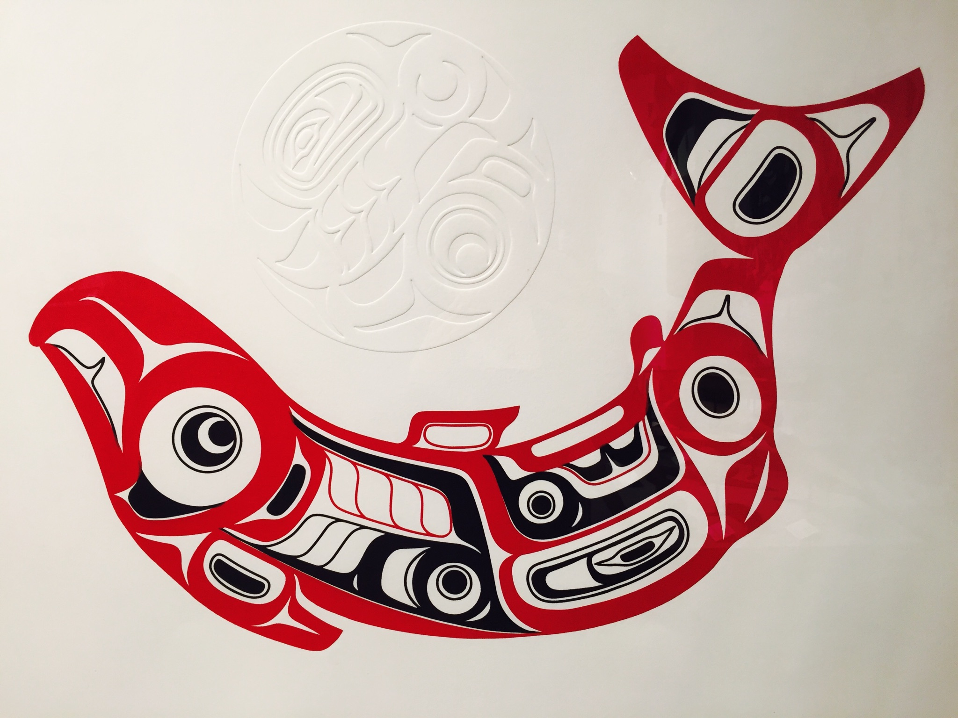
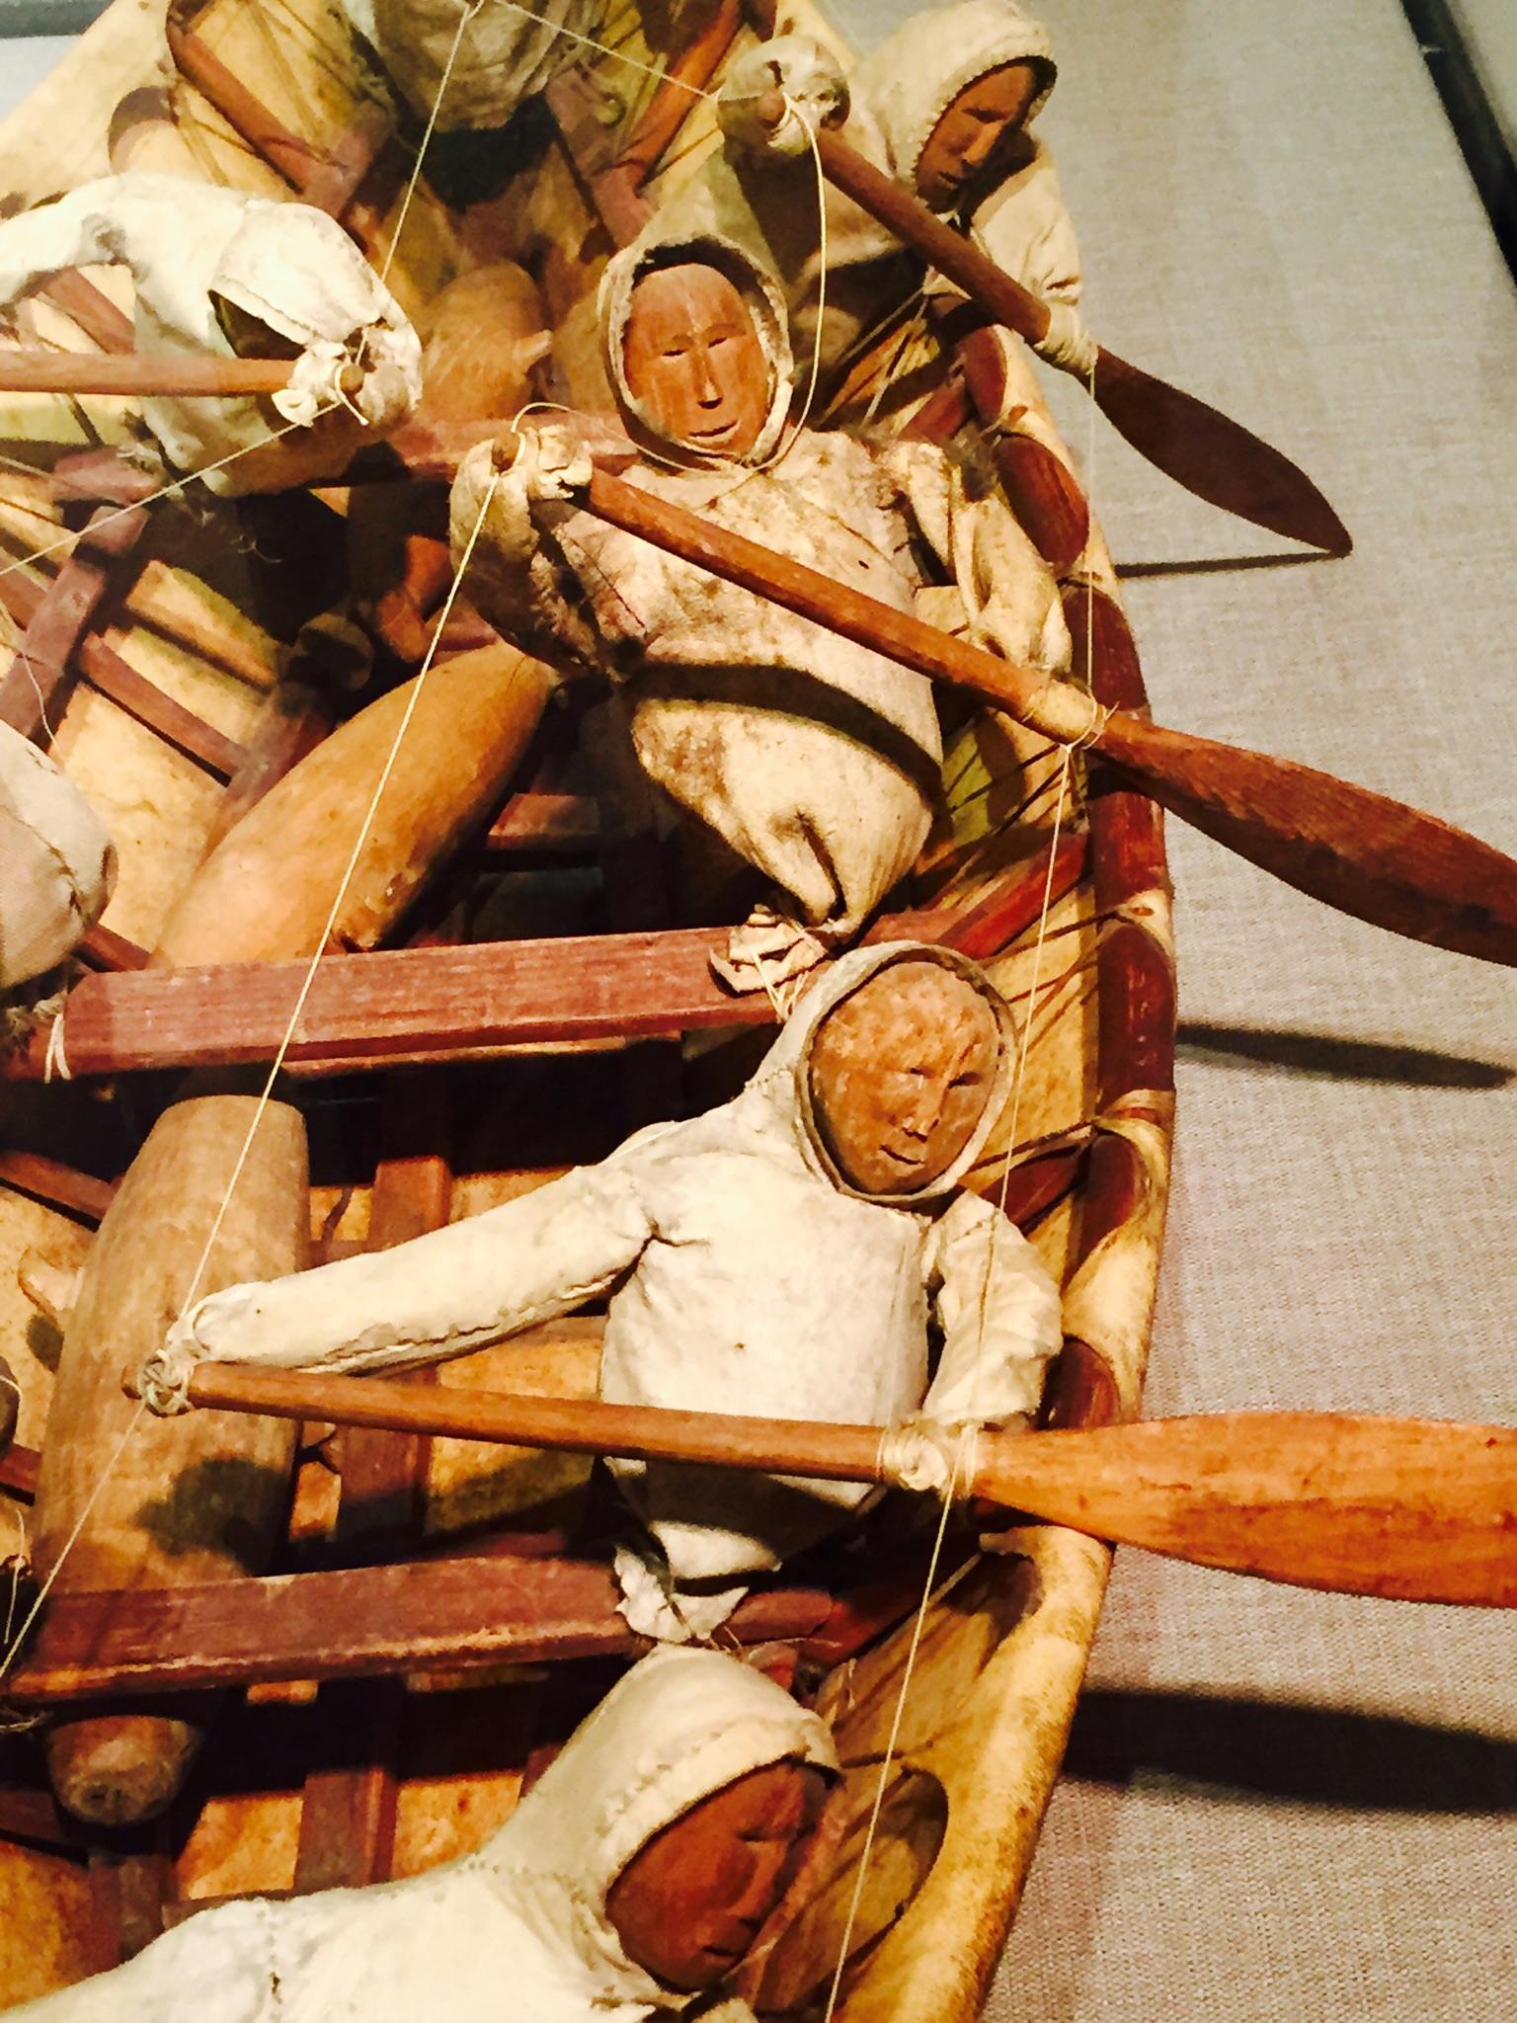
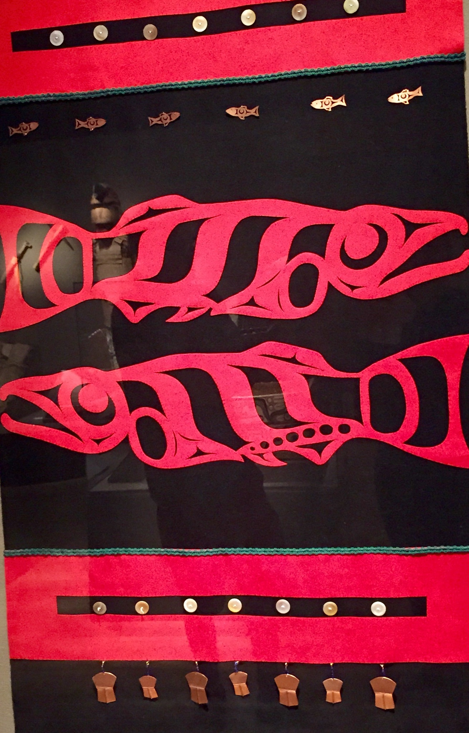

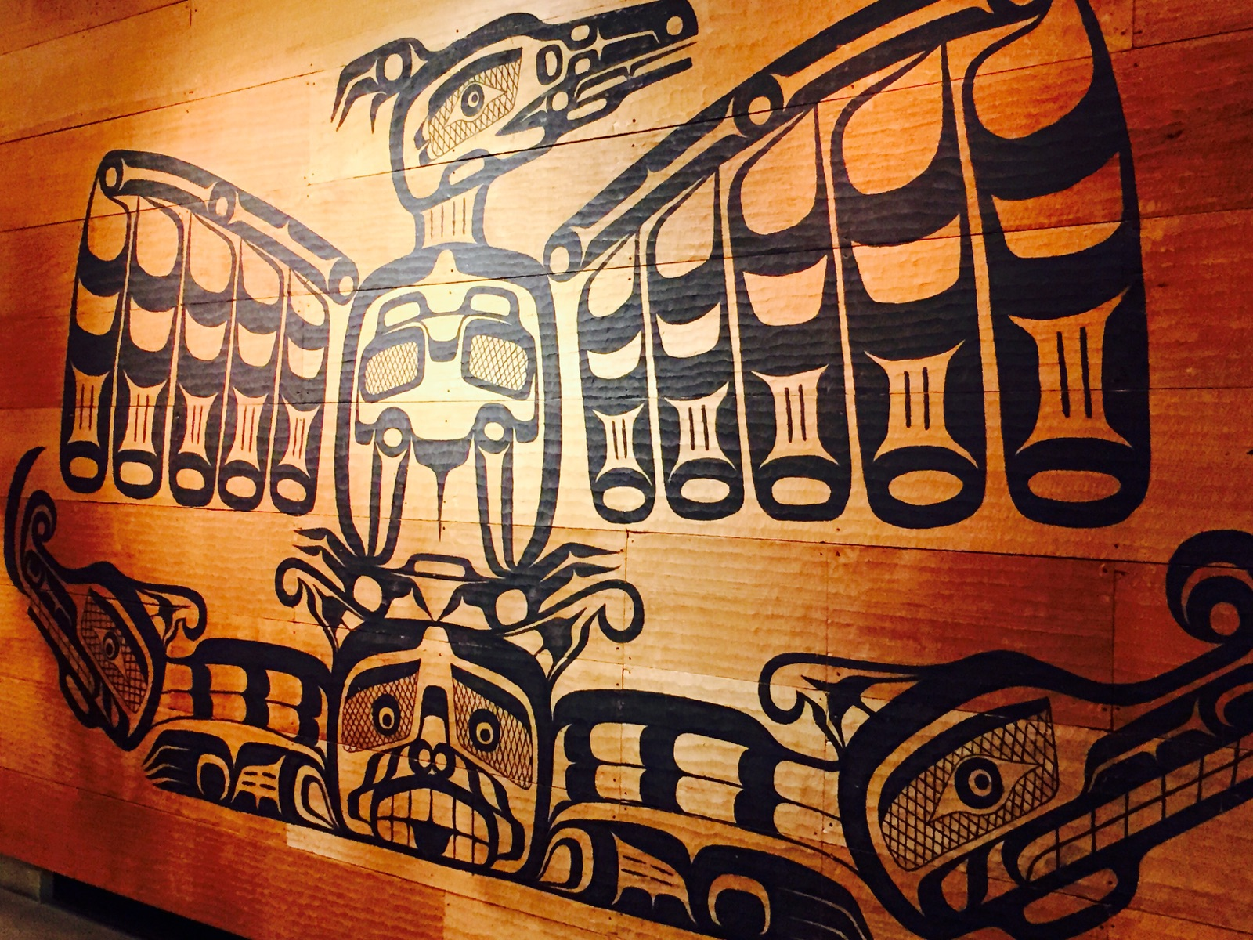
Picture 4: The raven, a commonly depicted animal in traditional Native American artwork, is also a feature of Pacific Northwest wildlife.
Picture 3: There are strong ties between the water, an ever-present aspect of the PNW environment, and Native American Culture, as is often depicted in traditional art.
Picture 2: Another depiction of salmon in a traditional Native American art piece, again illustrating salmon as an a strong influence in Native American art.

