Talia Kostal
August 19, 2015
San Juan Island Field Trip Report

Synopsis/ Reflection:

The trip to the Friday Harbor Labs was an incredible experience. Before going on the field trip, I did not know what to expect. I have been to Friday Harbor before, however never with the intent of leaning about whales, or visiting the UW labs. While the entire trip was a great experience, there were three main highlights for me. My favorite part was the first day when we spent the majority of the afternoon at Lime Kiln Point State Park. Having the opportunity to see the whales through the binoculars was incredible. Living in the Pacific Northwest, it is common to hear and talk about Orca whales. However having the opportunity to actually see them in person was breathtaking, and a valuable learning experience. The most incredible part of the afternoon at Lime Kiln was when we were driving back, and pulled over on the side of the road to view more whales. Seeing their faces through the binoculars was like nothing I had experienced before. The second highlight of the trip was our stop at South Beach. I enjoyed having our whale reading discussion on the beach. It was such a perfect setting to discuss what we had learned from the readings, particularly within the context of what we had observed throughout the day. Learning in the field is something new to me, and I find it much more enjoyable than being in a classroom. The third highlight of the trip was the tour of the Friday Harbor labs that we took the second morning. Hearing about the classes offered year-round at the labs made me wish that I had more time, and that I was not a super-senior. There are so many opportunities I have not had the chance to explore. Honestly, I wish I could be a student forever! Before this trip, I don’t think I realized how much I am going to miss UW after I graduate in the spring, nor how much I would have loved to have a third major. Overall, taking a fieldwork class has been a completely new experience, and I have really enjoyed learning through field trips instead of in the classroom. The San Juan Field trip was significantly longer, and thus more intense, than our normal weekly adventures. Although I was exhausted when I returned home, it was worth it.

Photo essay:
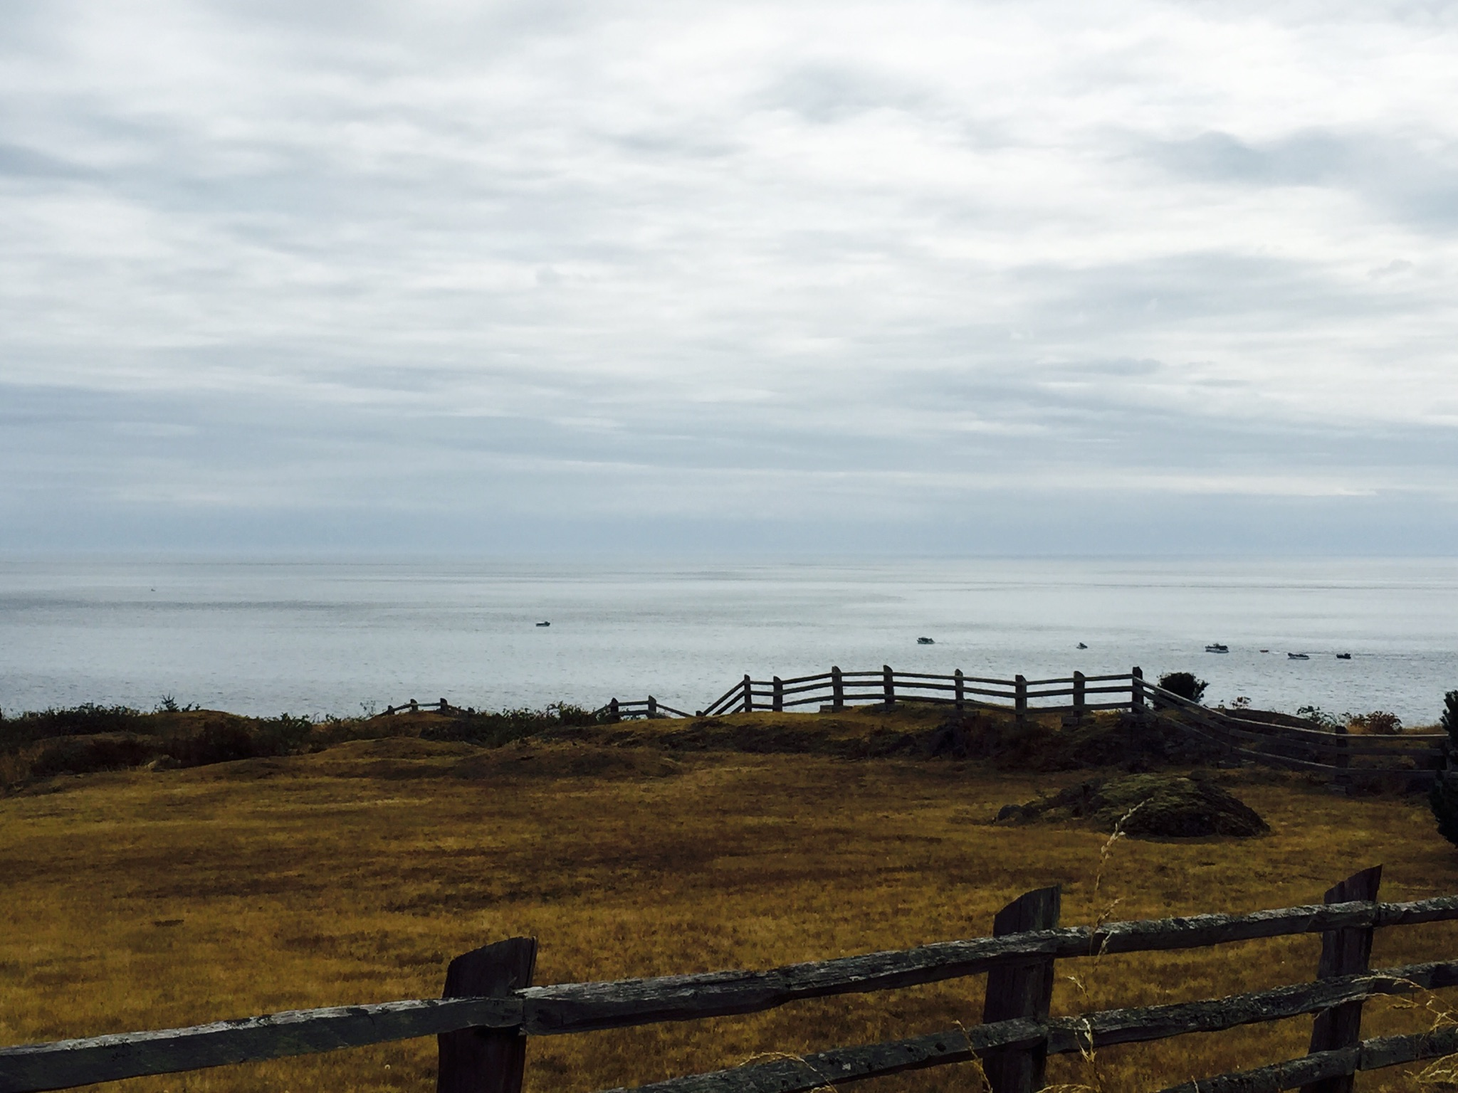
Landscape: I choose to include this landscape because of the stark contrast between the vast open space and the rolling hills with that of the whale watching boats in the distance. I think it is a metaphoric representation of the environment the whales live in in Puget Sound. While it may seem at first glance that the landscape is peaceful and remote, upon further examination it becomes clear that one is not really alone with nature.

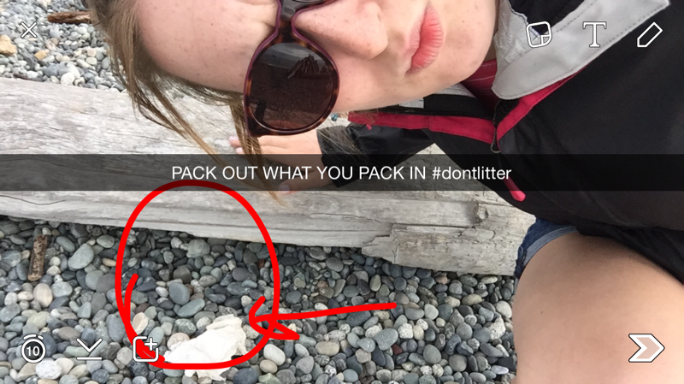
The selfie is designed to send a message that littering is a problem, and it is not okay. I saw a sign at Lime Kiln State Park that said something along the lines of “leave no trace – pack out what you pack in.” I thought this was a catchy phrase that got the point across well.

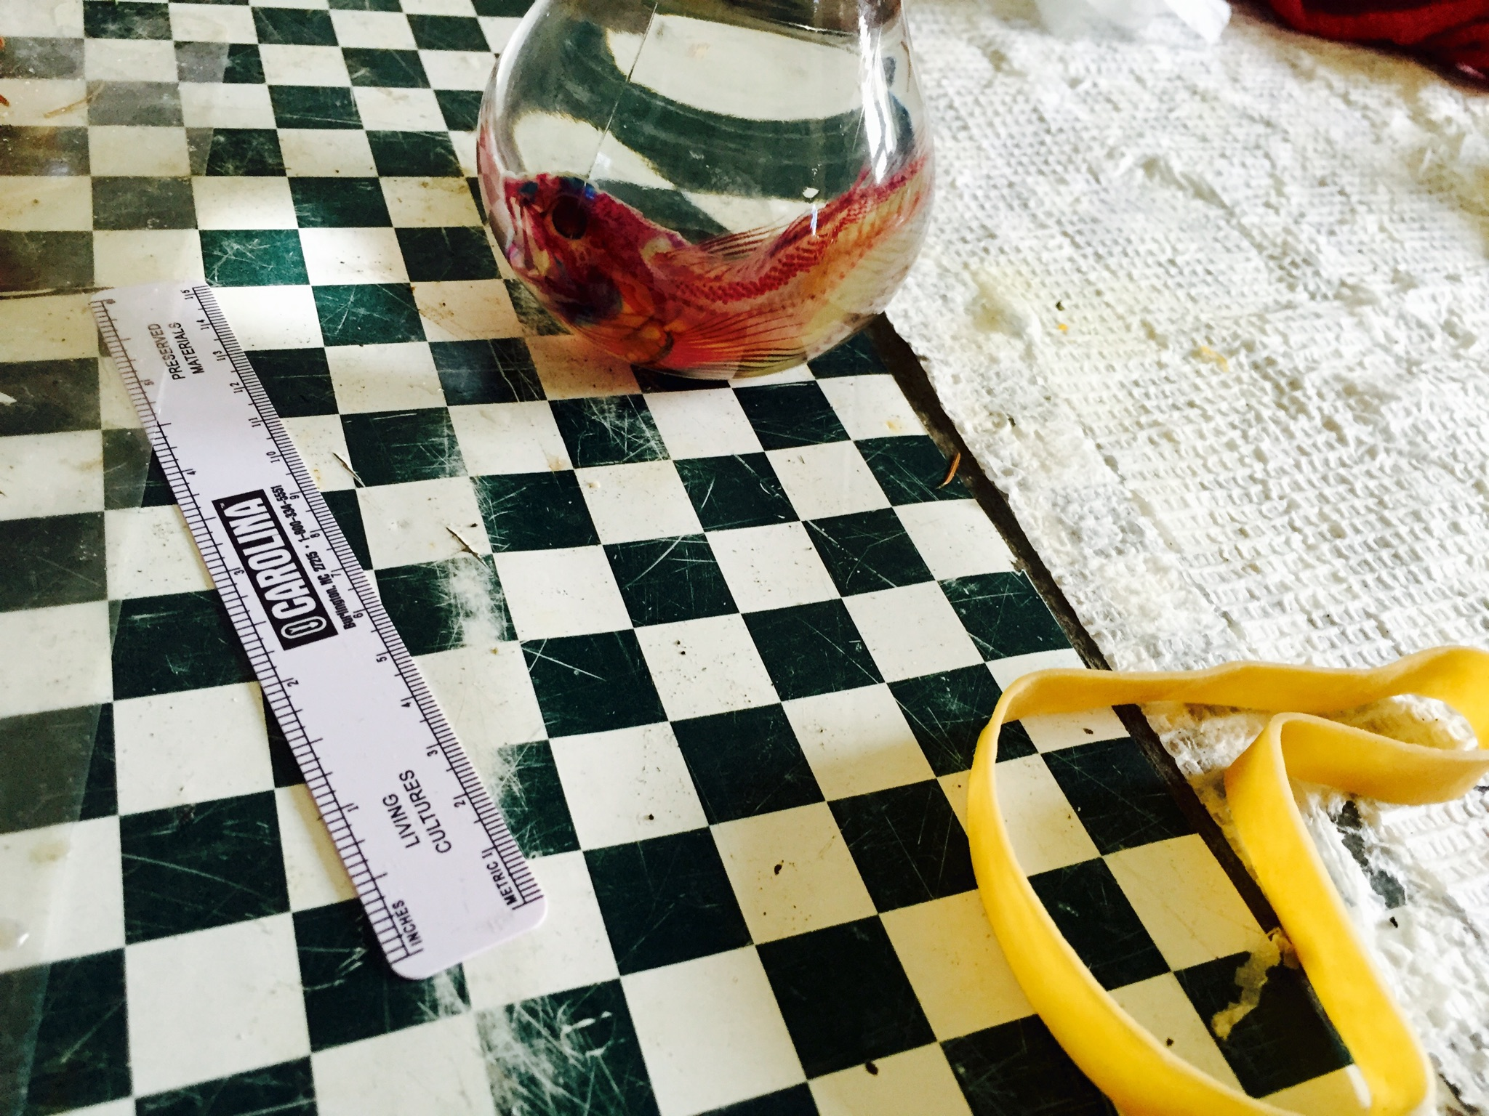
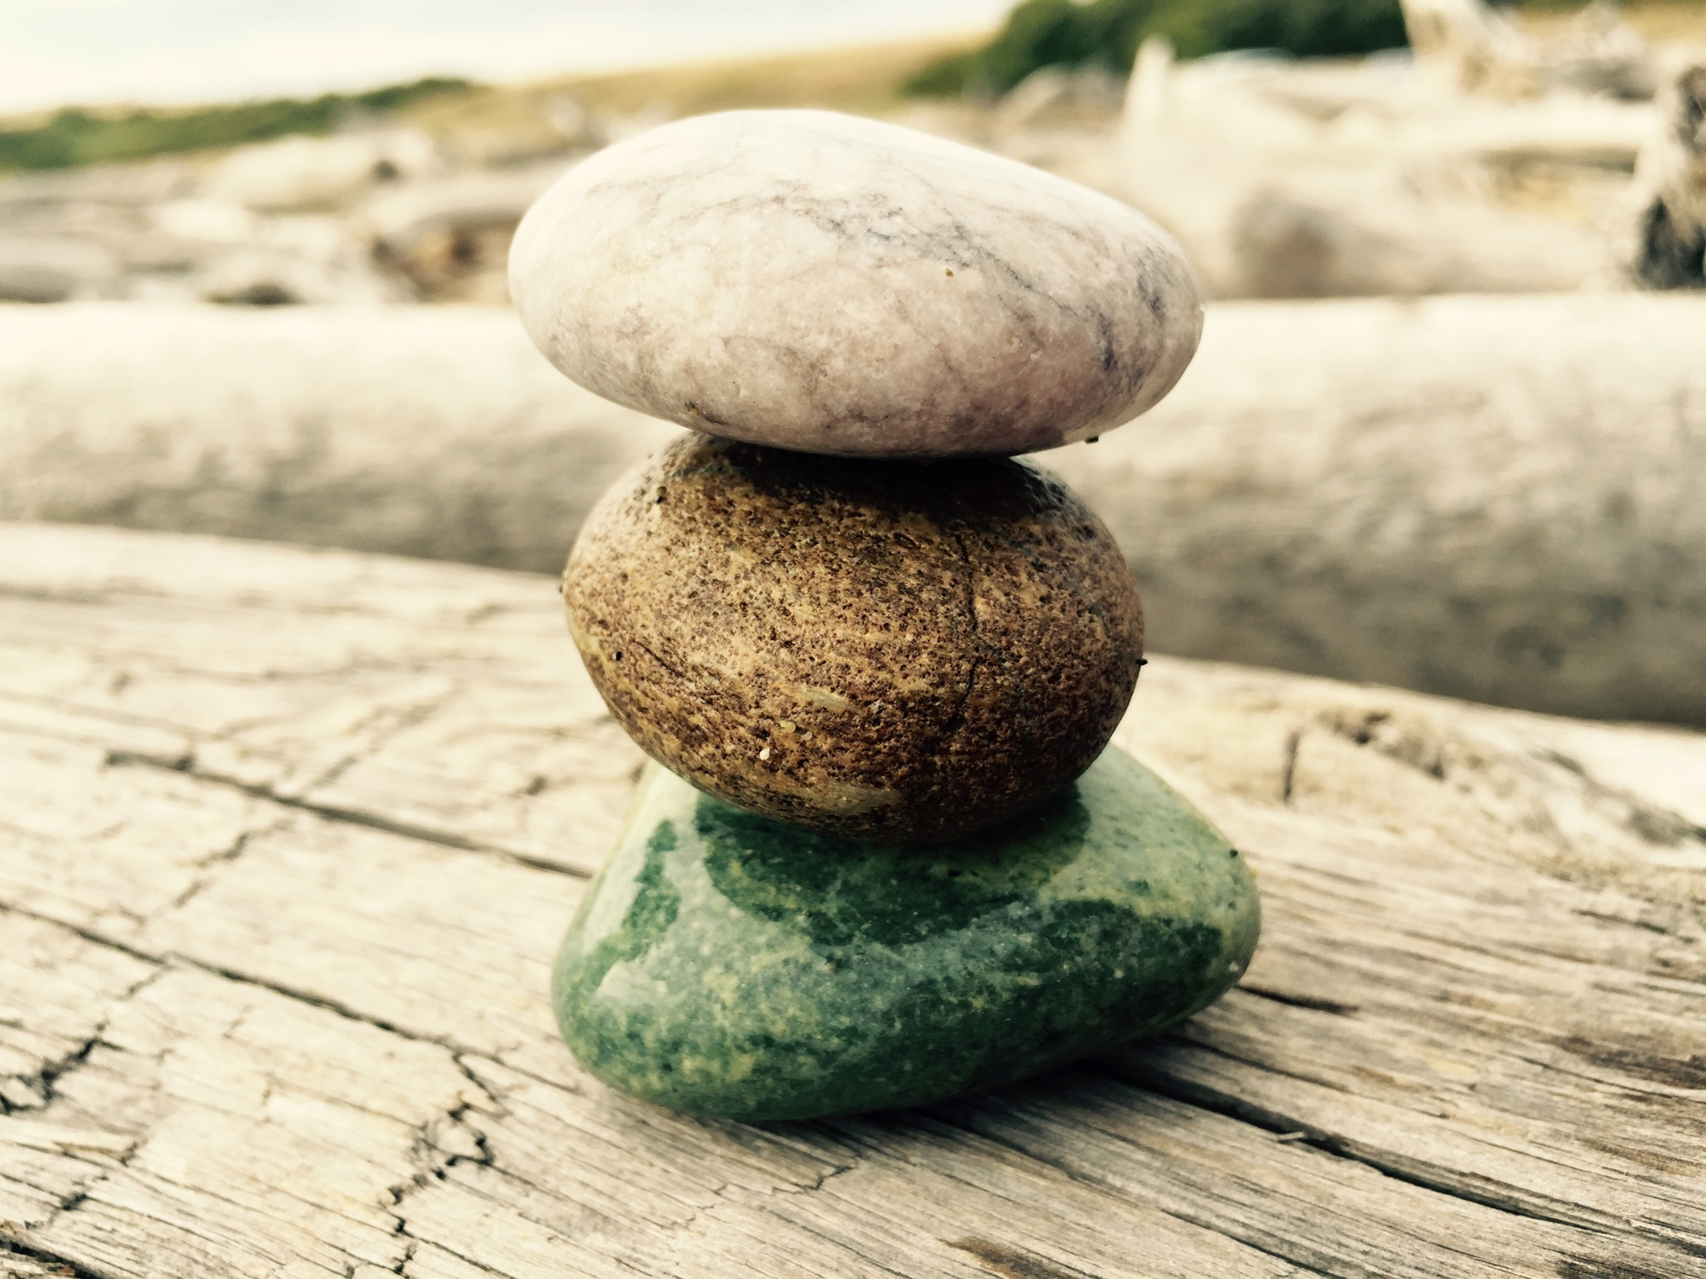
Trio 2: I saw this trio in one of the labs we toured at Friday Harbor. It was already arranged (must have been left there by the researchers). I loved how the research subject (the red fish) was juxtaposed with the research tools.
Trio 1: I found these rocks at South Beach. I was struck with how vastly the colors differed yet how round and consistent the shapes remained.

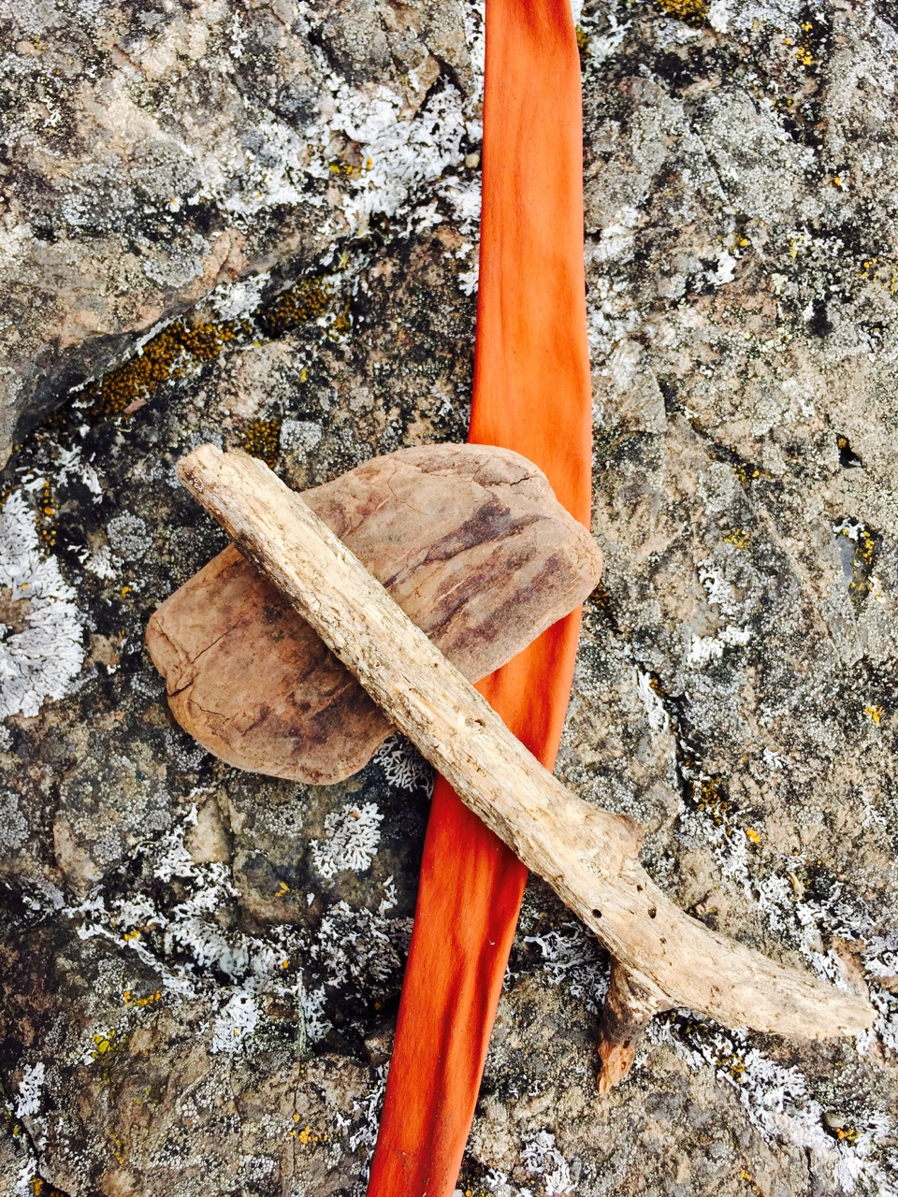

Trio 3: The theme of this trio is the different barks present at Line Kiln State Park. I think it is incredible the diversity I was able to find just while walking along the dirt path.

