Talia Kostal
Bird Day Journal
August 11, 2015

Why Study Birds?

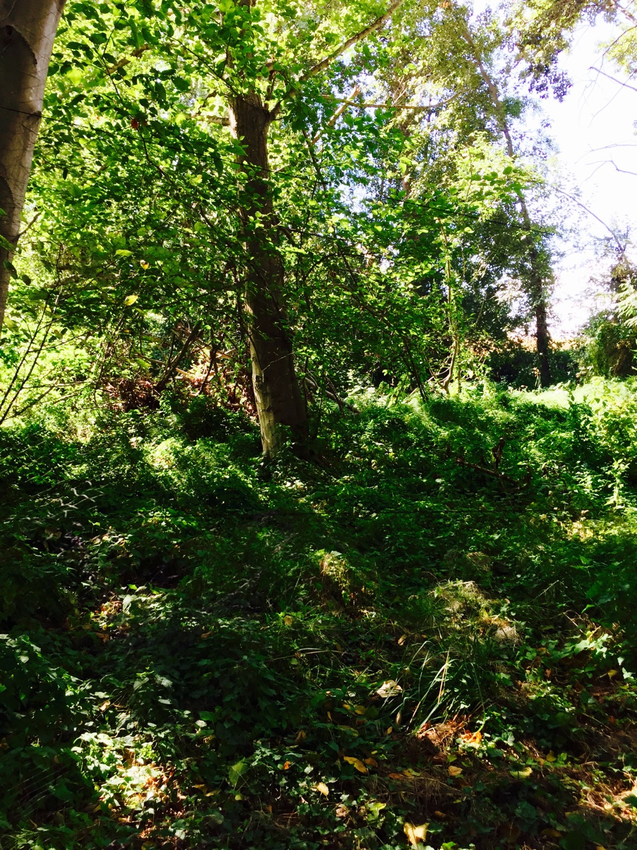
Studying birds is important for many reasons. I think one important reason to study birds, similar to the way we learned about in class (observing, catching, and collecting data), is the information that it can give us about species diversity and distribution of either a particular species or set of species. Additionally, bird research can allow researchers to better understand the movement and migration patterns of a particular set of birds. Having an understanding of such concepts allows us, as researchers, to compare data trends between and among species, track changes over time, and analyze the results within the greater social and environmental context.

The species diversity present in this part of UW land is incredible. I never even knew it was here!

Birds & Humans:

Depending on the species of bird, there are many different connotations that birds carry for human interpretation. For example, songbirds, such as hummingbirds, tend to carry a positive association when interacting with humans in their environment. They represent a positive connection between humans and birds: people invest money and time to make yards attractive to hummingbirds, and such serves to increase environmental awareness and investment from the human standpoint. In contrast, birds can also be viewed as disease carrying, as well as pests. “Bird-flu” and the fears of a widespread avian flu epidemic represent an example of the negative connections shared between birds and humans.
Reflections on Bird Day (the ID & research experience):

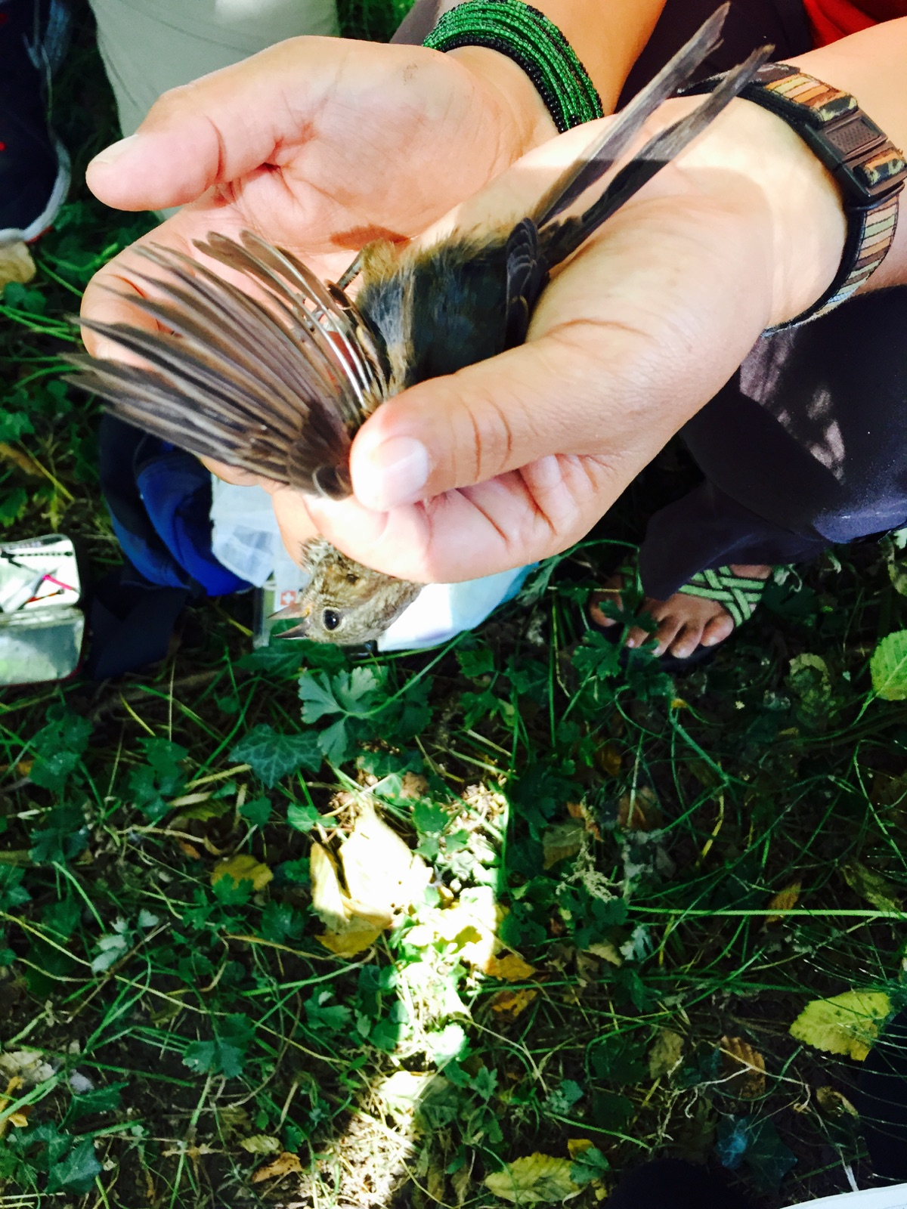
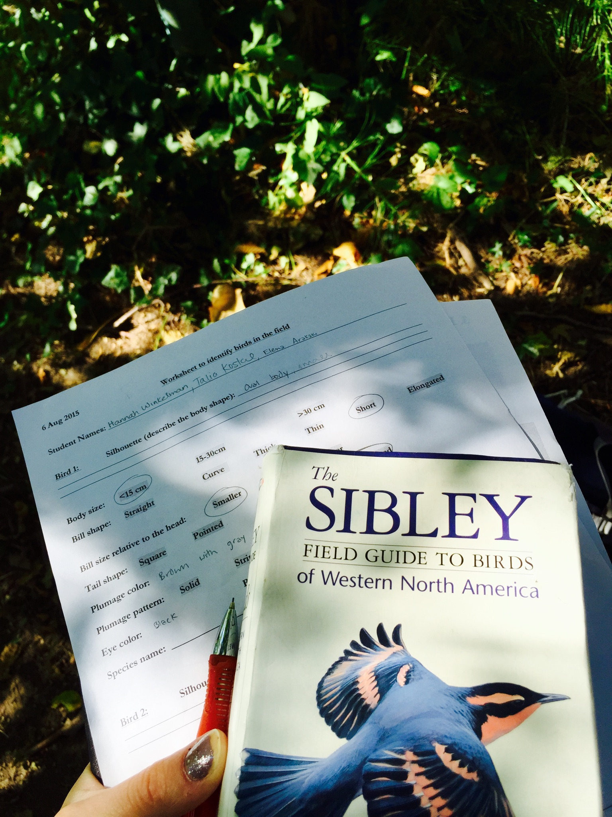
The bird ID experience was a lot different than I had initially expected. When described that we would be catching birds in a large net, and then examining them, I imagined something much smaller in scale. I was surprised and awed when the actual net was revealed. I had no idea it would be so large, nor so difficult to see. Once I saw the net, I thought that it would not take very long to catch multiple birds. However, I was wrong! It took over an hour to catch our first bird. During that time, my partners and I searched for birds with binoculars in the surrounding trees. As an inexperienced bird observer, it was difficult for me to find birds with the binoculars. When I finally would find a bird, it was hard to quickly analyze and document the phenotypic features before it flew away again. Based on the little information I was able to gather from looking through the binoculars at the birds, it was difficult for me to feel confident in accurately identifying the birds from the book. Once we caught birds in the net, it was easier to closely observe and document our findings. However, even having the ability to look closely at the birds we caught, I still felt unsure and somewhat overwhelmed in trying to identify the species based on what I observed.
It was significantly easier to gather data after we caught the bird and we able to examine it up close. Here the budding wing feathers can be clearly seen in this juvenile sparrow.
Identifying the birds based on our quick observations (as recorded on the white sheet) was more difficult than anticipated.

Reflections on Bird Day: Learning & Personal Experiences

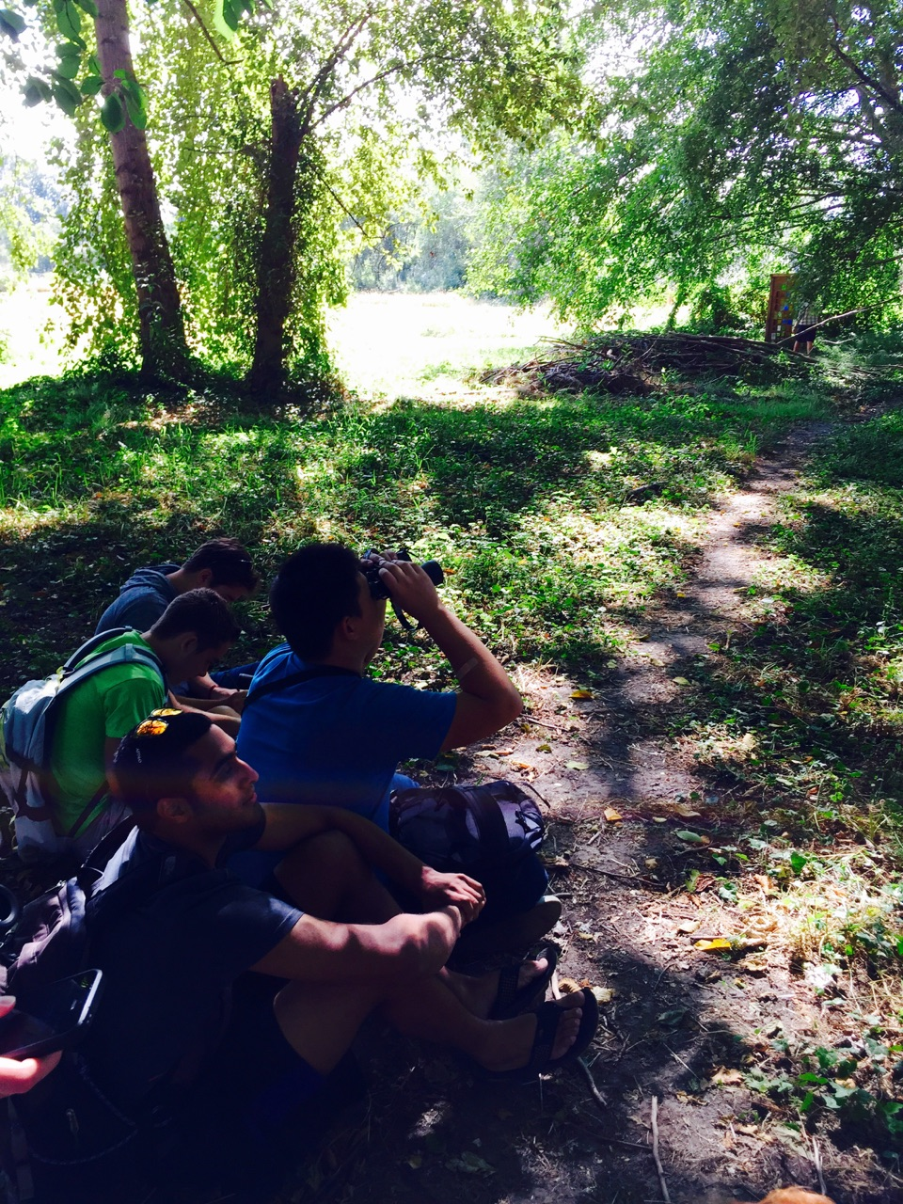
I learned a tremendous amount during this field trip. I was most struck by the fact that bird research takes so much time. We spent the majority of the morning attempting to catch two birds. I now have a much greater appreciation for the research methods used in bird studies. Through this experience I learned that bird research takes a lot of time, and requires a significant amount of patience and skill. I will admit, it was difficult for me to be patient while waiting to catch the birds. I was so excited to get the opportunity to see birds up close, as this was a completely new experience for me, I found patience was difficult to muster, especially since I wasn’t expecting it to take so long! I was also struck by the diversity of birds present in the location we visited. Having attended UW for four years, I never knew there was a place with so much bird diversity right on campus. It was interesting to learn that there is so much that can be researched literally in our backyard!

We spent the majority of the morning waiting and looking through binoculars. This was a more different experience than I was initially expecting.

