Talia Kostal
August 19, 2015
Ballard Locks Journal Report

History of the Chittenden Locks & the salmon that use it
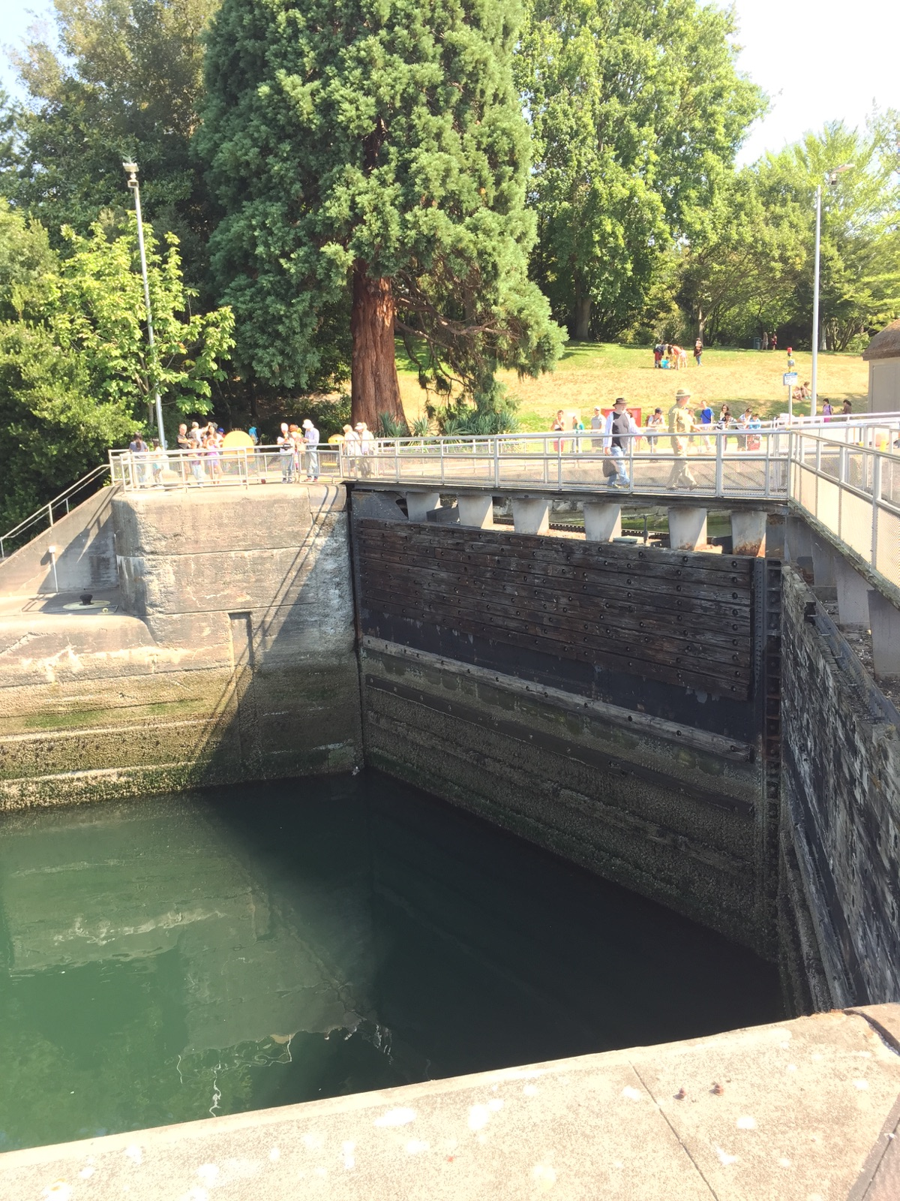
The Locks that opened in 1917 are still heavily used today, almost 100 years later. It is incredible to me how long they have lasted. I wonder how many times those gates have opened and closed.
The Chittenden Locks were designed in order to connect Lake Washington, Lake Union, and Salmon Bay. The original idea for the locks was surfaced in 1854 by Thomas Mercer. Six decades later, in 1911, the US Marine Corps began the massive $3.5 million construction project. On July 4th, 1917 the Chittenden Locks, including the salmon ladder, officially opened to the public. The salmon ladder is a very important aspect of the Locks. Salmon spend the majority of their life in the ocean. However, after approximately four years in the open sea, salmon retrace their journey back to where they hatched (often tributaries of Lake Washington) to return to their original breeding grounds to spawn prior to dyeing. If the salmon ladder did not exist, the five major salmon species (Chinook, Coho, Sockeye, and Steelhead) would not be able to return to their breeding grounds and reproduce.

Importance of Salmon in the PNW

Salmon is a very important species in the Pacific Northwest for a number of reasons. Culturally, salmon play an integral part of Native American culture. Economically, the salmon fishing industry is a huge economic force in the PNW. Ecologically, the resident orca whale pods that live in Puget Sound and the Salish Sea feed exclusively on salmon. For these reasons, maintaining and protecting the dwindling salmon population in the PNW is very important.

Threats to Pacific Salmon

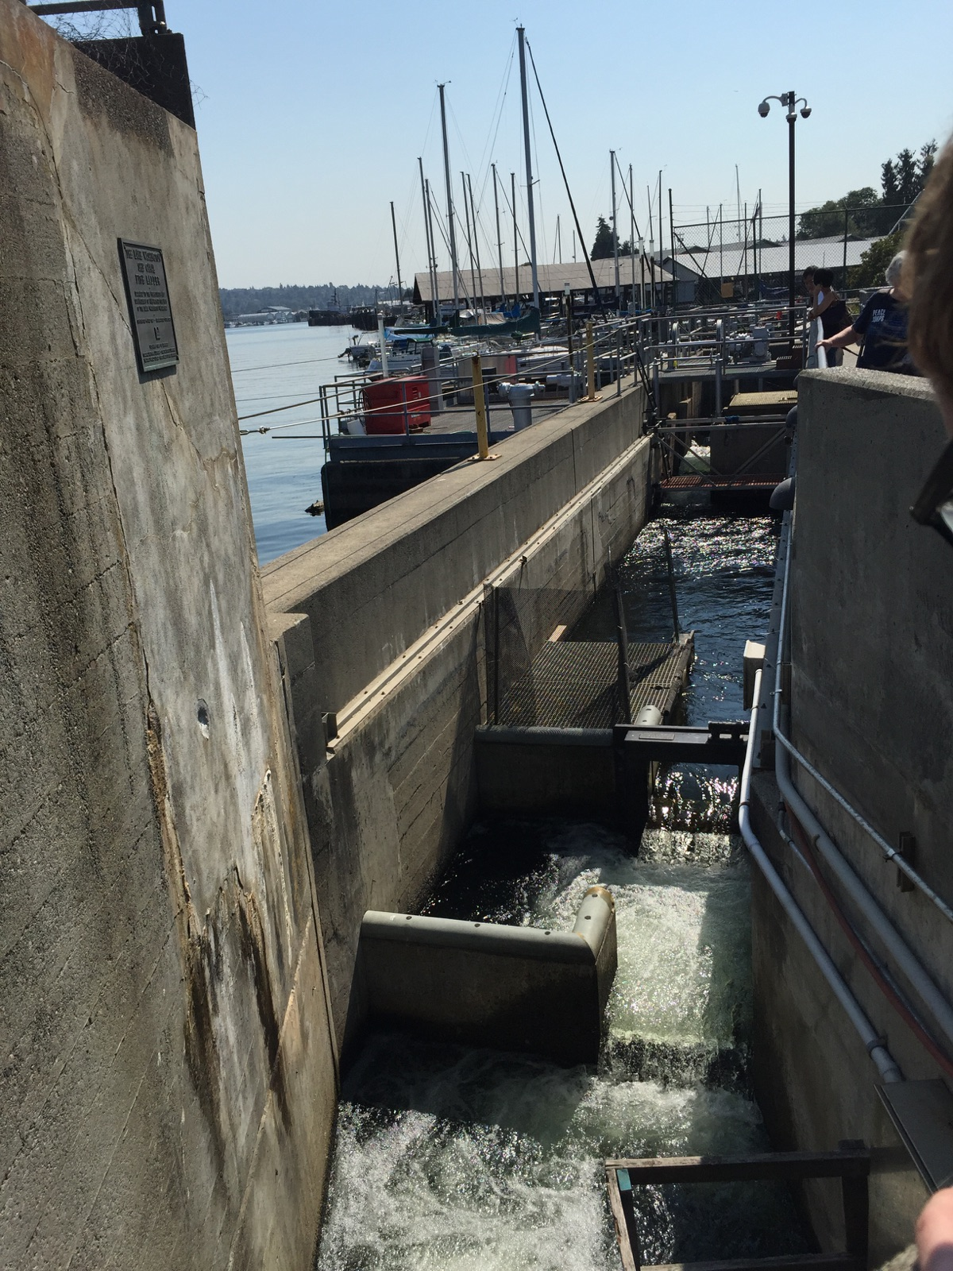
There are several main threats that the five species of Pacific Salmon face. One major threat is the warming waters in the PNW, made worse by unrelenting droughts. Warm waters threaten salmon for a variety of reasons, primarily being that it causes health issues such as gill rot, as certain bacteria breed in warmer waters. Additionally, large numbers of Steelhead salmon released by hatcheries in the PNW in an attempt to increase salmon populations in the area has been shown to have a negative impact on the survival of Chinook salmon. Other causes of species decline include the construction of dams, overfishing due to improper regulations, and habitat destruction. Of the five species of Pacific Salmon, Chinook and Sockeye are considered endangered.
Without the salmon ladder, the fish would be unable to pass through these large locks. Many would either be unable to make the journey, or be killed by vessels while in the chambers.

Narrative and Reflections: Salmon Research and Data Collection
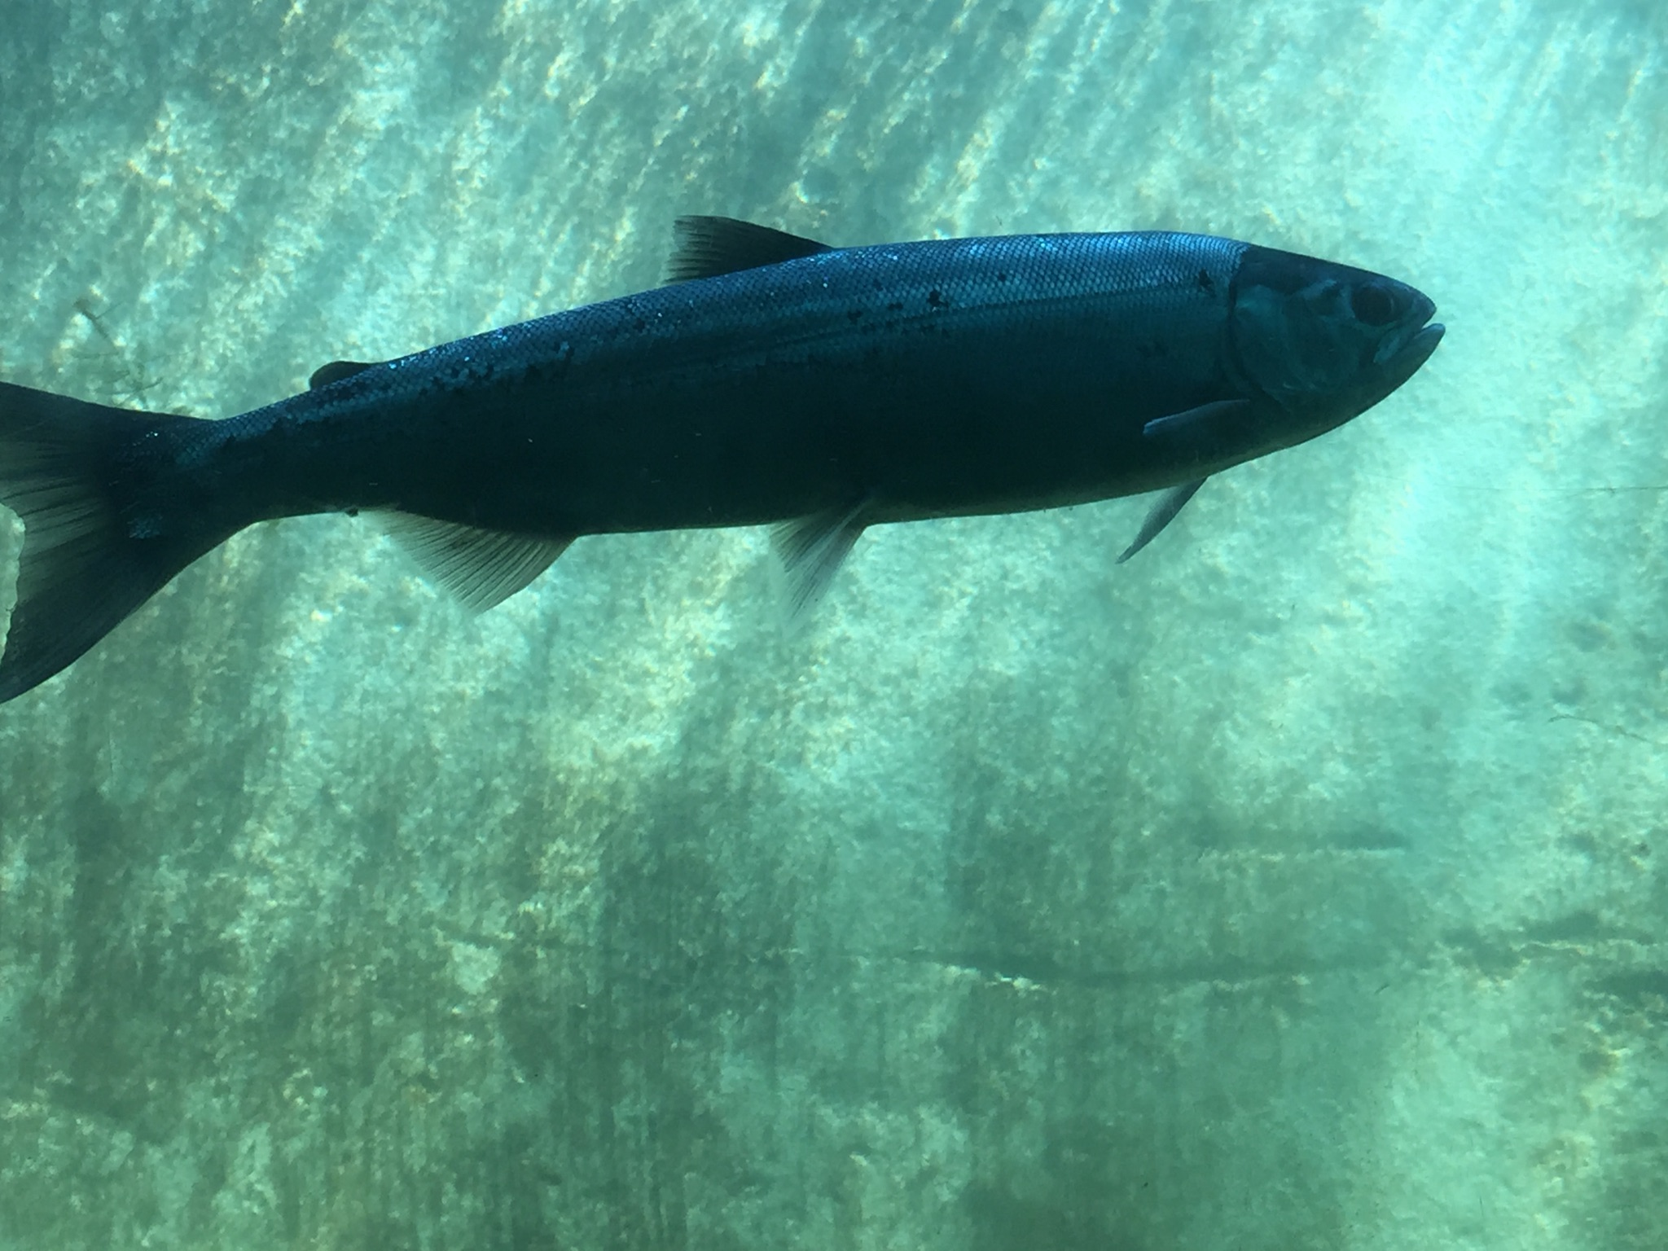
The visit to The Chittenden Locks was interesting from an educational standpoint, however somewhat disappointing due to the fact that we did not have the opportunity to see many salmon using the salmon ladder. Unfortunately since the tide was not in favor of the salmon using the ladder, we only saw 2-4 fish. At a time where there were more fish utilizing the ladder, this would be an excellent location to study and observe salmon. Due to the fact that this is the single access point that all salmon must travel through to return to their breeding grounds, it is a prime area to observe the salmon population in the PNW.
This is one of the only salmon I saw while observing the salmon ladder. Although it was disappointing to not see many fish, the small number did allow me to examine the few I did see in great detail!

Personal and Educational Reflections
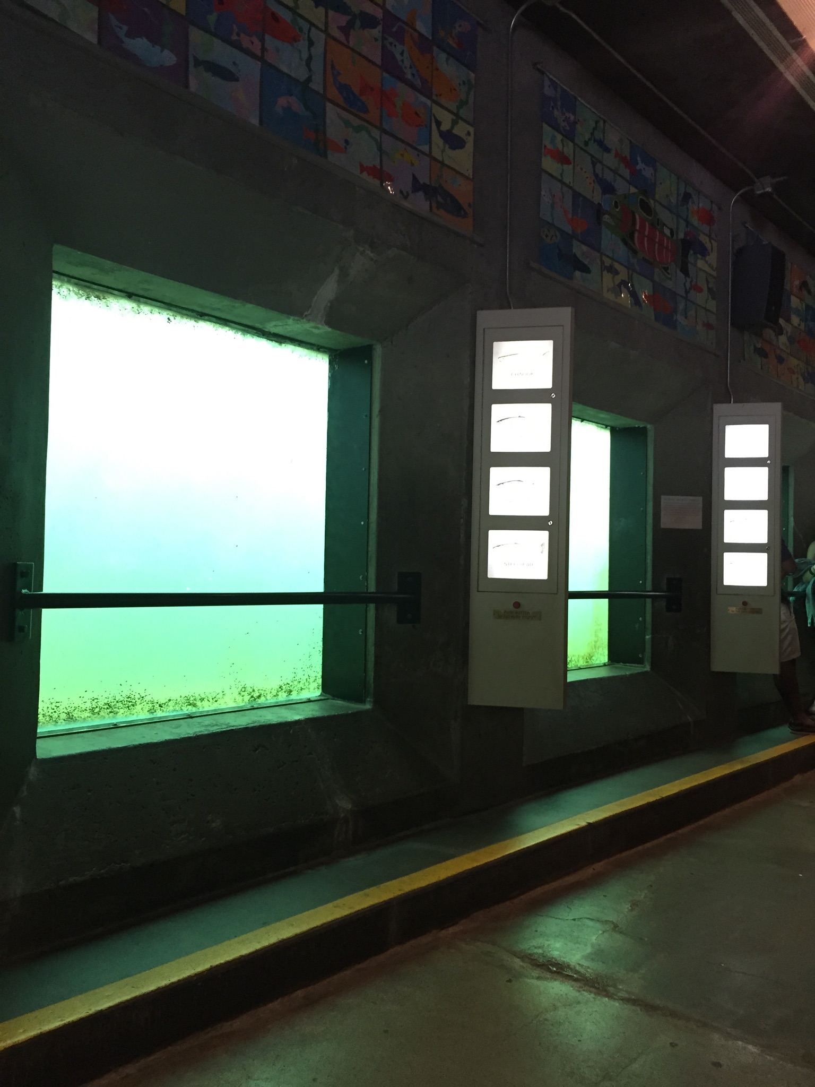
Although seeing such few salmon was somewhat disappointing, it was a good experience to have, as it severs as a further reminder that research and data collection take time, and necessitate patience. Despite the fact that I did not get to collect as much data about salmon as I had hoped, it was, as a personal experience, really special to go to the Locks. I have not been there since I was a young child, and it brought back a lot of memories of being a kid. It was nice to take the time to remember!

The empty windows of the salmon ladder serve as a reminder to be patient and remember research takes time!

